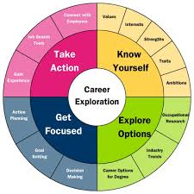**Introduction to Business  
Career Report/PowerPoint**

Choose a career and create a PowerPoint presentation about it to share with your classmates.

Presentation Basics:

* Add a background to your presentation.
* Each slide must contain brief points of information, not paragraphs.
* Your font must be at least size 20.
* You must add at least 3 images to your presentation.
* Add **animations** to your information.
  + I will help you if you don’t know how.
* Your presentation must have appropriate spelling and grammar and be error free.
* Print 9 slides per page & email to [tellsworth@fillmorecsd.org](mailto:tellsworth@fillmorecsd.org)
* This presentation WILL be shared with your classmates

Create a slide for the following information:

* Slide 1 - Career Name & Your Name
* Slide 2 - What your chosen career does
* Slide 3 - How to become a…education required
* Slide 4 - Work Environment
* Slide 5 - Pay (explain - per year and per hour)
* Slide 6 - Job Outlook, 2023 – 33
* Slide 7 - Similar Occupations (@ least 3)
* Slide 8 – Why did you choose this job? Explain.
* Slide 9 – Resource Slide (Occupational Outlook Handbook)